# **What you know about c#?**

* **C# (C-Sharp) is a programming language developed by Microsoft that runs on the .NET Framework.**
* **C# is used to develop web apps, desktop apps, mobile apps, games and much more.**
* **It is an object-oriented programming language created by Microsoft that runs on the .NET Framework.**
* **C# has roots from the C family, and the language is close to other popular languages like**[**C++**](https://www.w3schools.com/cpp/default.asp)**and**[**Java**](https://www.w3schools.com/java/default.asp)**.**
* **The first version was released in year 2002. The latest version, C# 11, was released in November 2022.**
* **C# is used for:**
* **Mobile applications**
* **Desktop applications**
* **Web applications**
* **Web services**
* **Web sites**
* **Games**
* **VR**

# **Why to use c #?**

* **It is one of the most popular programming language in the world**
* **It is easy to learn and simple to use**
* **It has a huge community support**
* **C# is an object oriented language which gives a clear structure to programs and allows code to be reused, lowering development costs**
* **As C# is close to**[**C**](https://www.w3schools.com/c/index.php)**,**[**C++**](https://www.w3schools.com/cpp/default.asp)**and**[**Java**](https://www.w3schools.com/java/default.asp)**, it makes it easy for programmers to switch to C# or vice versa.**

# **Show the C# Syntax?**

* 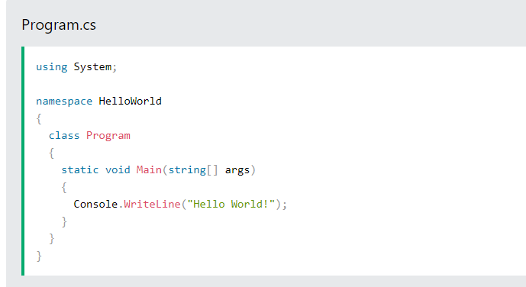

# **How would you show c# output?**

* **To output values or print text in C#, you can use the WriteLine() method:**
* 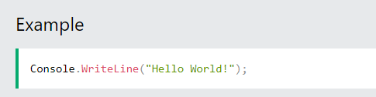

# **Talk about Comments ?**

* **Comments are :**
* 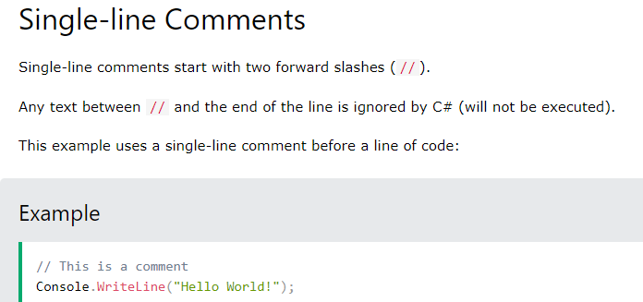
* 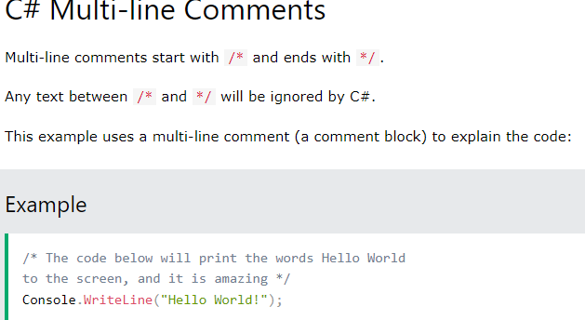

# **What are variables ?**

* **Variables are containers for storing data values.**

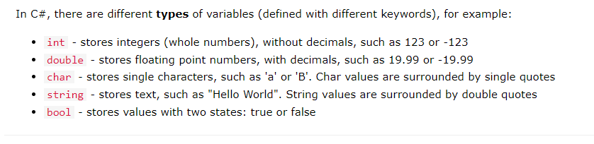

* 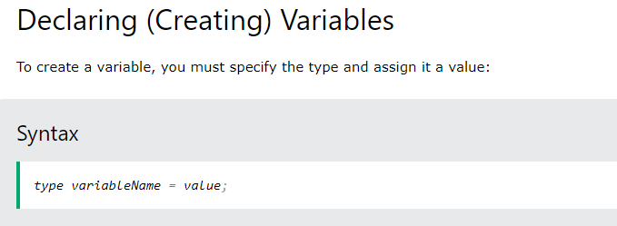

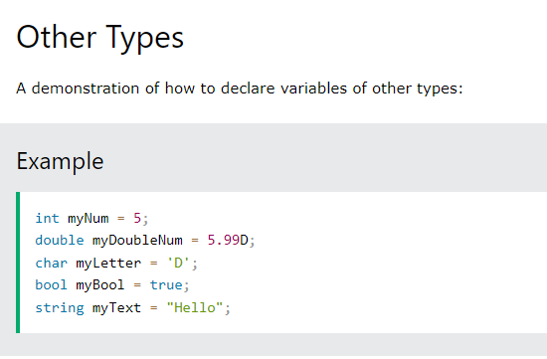

# **What are Constants Variable?**

* **If you don't want others (or yourself) to overwrite existing values, you can add the const keyword in front of the variable type.**
* **This will declare the variable as "constant", which means unchangeable and read-only:**
* 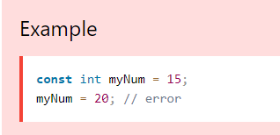
* 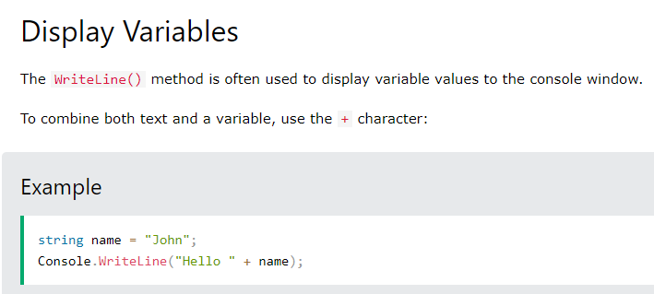
* 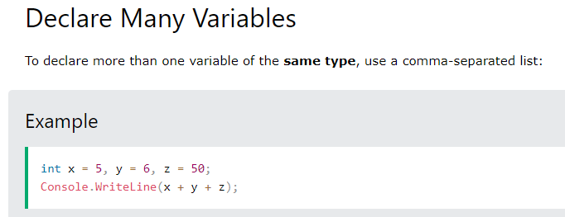

# **What you know about Identifiers ?**

* 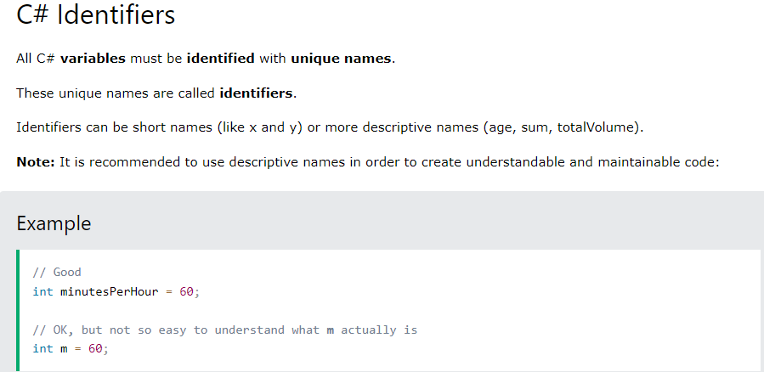

# **What you know about Data Types ?**

* **A data type specifies the size and type of variable values.**
* 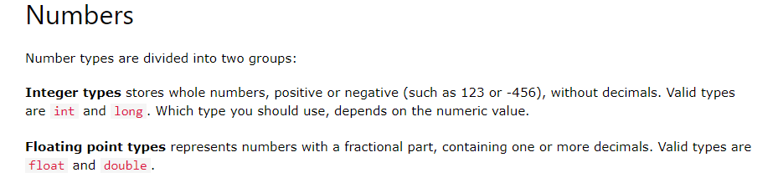
* 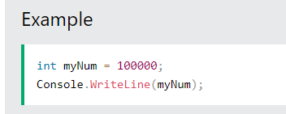
* 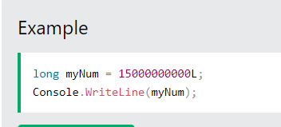
* 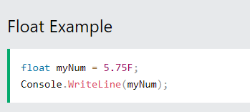
* 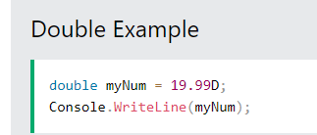

# **What you know about Type Casting ?**

* **Type casting is when you assign a value of one data type to another type.**
* 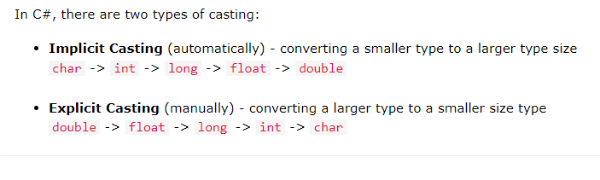
* 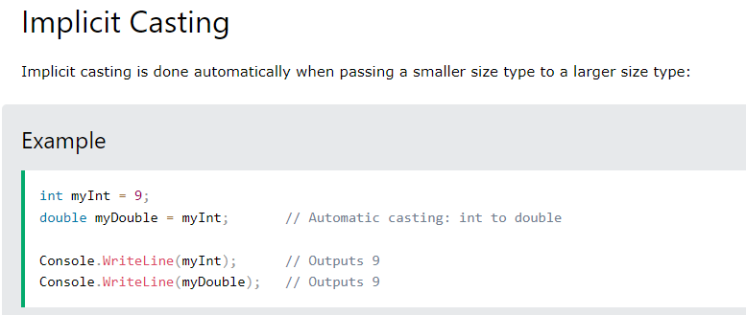
* 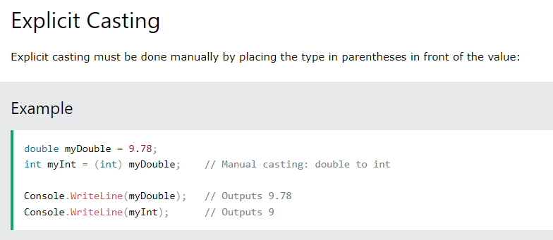
* 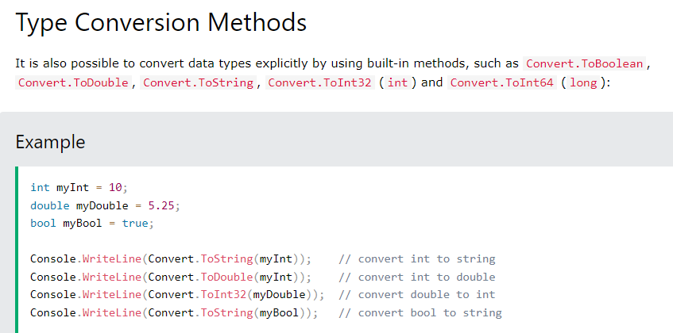

# **Get User Input ?**

* **You have already learned that Console.WriteLine() is used to output (print) values. Now we will use Console.ReadLine() to get user input.**
* 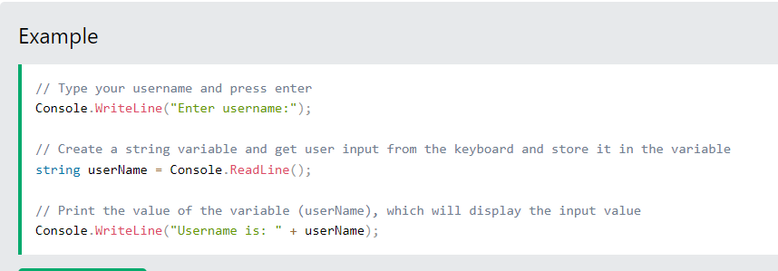

# **What is Boxing and Unboxing ?**

* 